AUTHOR: Beyer, David M  
TITLE: Harmonic Matrix Analysis of Otto’s Violin Octet  
KEYWORDS: Just Intonation, spectralism, harmony, Helmholtz-Ellis, color, MaxMSP, microtonal, violin, octet, synesthesia

ABSTRACT:

By applying Harmonic Matrix analysis to Chris Otto’s Violin Octet, it is possible to visualize the Just Intonation harmony by mapping pitch class to hue, harmonic spectra to the x-axis, and sub-harmonic spectra to the y-axis.

Otto’s 2-hour octet employs polyrhythms to explore slowly evolving microtonal textures, which morph between lush harmony and otherworldly timbres. Otto’s analysis of his octet divides the piece into 9 sections, each with pitches based on the harmonic spectra of the fundamental related to 42Hz by small whole number ratios.

Utilizing a MaxMSP patch called, “the Harmonic Matrix for Analysis,” color graphics were generated with a 32x16 pixel size, each corresponding to the harmonies in sections 1, 2, and 9 of the Violin Octet.

The pixels in the Harmonic Matrix graphics number from left to right 1-32 on the x axis, and from top to bottom 1-16 on the y-axis. Each brightened pixel at a location (x, y), corresponds to a frequency calculated by the equation: 42Hz \* x / y. The hue of the brightened pixel is mapped to pitch class.

Accompanying written analysis of the Harmonic Matrix graphics reveal how the composer utilized ear-tunable small frequency ratios in order to provide a consonant context for microtonal cluster chords, beating, and combination tones.

David M Beyer

University of Iowa

School of Music

93 E Burlington St

Iowa City, IA 52240

**Harmonic Matrix Analysis of Chris Otto’s Violin Octet**

**I. Accidentals**

[1.1] The noteheads on a conventional musical staff display coarse pitch on the y axis, as a function of time on the x axis. Accidentals modulate this course pitch, and can supersede the pitch hierarchy suggested by the y-axis. While physically located higher on the y-axis, an A-double-flat sounds to the listener lower than a G-sharp. In addition to conveying fine pitch adjustments, accidentals can sometimes convey a structural harmonic relationship between musical pitches, which may or may not be expressed in pitch. For example, in a tonal context, the chord consisting of A-flat, C-natural, E-flat, and F-sharp may be interpreted as a German augmented sixth chord in the key of C-natural, while the chord consisting of A-flat, C-natural, E-flat, and G-flat may be interpreted as a dominant seventh chord in the key of E-flat major. While both chords sound pitch-wise identical on the piano, an expert pianist playing tonal music is likely to consider structural harmonic function when making choices about macrodynamics, microdynamics, tempo, and phrasing that are not indicated in the score.

[1.2] An accidental not only communicates pitch class, but also sends subtle cues to the performer, by referencing the history of tonal harmony and classical performance practice.

[1.3] With the invention of a new accidental, or a new system of accidentals, a learning barrier is created for the composition, performance, and analysis of music employing these accidentals. In a score with new accidentals, only the coarse pitch is available to most score-readers—the fine pitch, relation of consonance or dissonance to other pitches, harmonic function, and historical context cannot be seen.

[1.4] The pitch material of Chris Otto’s Violin Octet is notated using the Extended Helmholtz-Ellis JI Pitch System, created in 2004 by Marc Sabatz and Wolfgang von Scheinitz in order to provide “a method of writing any pitch-height in the glissando-continuum as a note on the five-line staff, and of specifying, in the case of any natural interval, the *harmonic relationships* [sic] by which this note might by precisely tuned.

[1.5] Extended Helmholtz deploys 67 newly invented accidentals in various combinations with traditional accidentals, whose meaning is re-interpreted from their equal-tempered definition. Traditional double-flats, flats, naturals, sharps, and double-sharps are understood in a Pythagorean sense, such that each pitch class is defined as a frequency ratio of 3/2 above the pitch class below it. For example, B-double-flat, F-flat, C-flat, G-flat, D-flat, A-flat, E-flat, B-flat, F, C, G, D, A, E, B, F-sharp, C-sharp, G-sharp, D-sharp, A-sharp, E-sharp, B-sharp, and F double-sharp would comprise 23 distinct pitches, each tuned an exact perfect fifth apart (~702 cents). In Extended Helmholtz-Ellis, the circle of fifths, as written in traditional notation, no longer wraps around.

[1.6] The first 62 invented accidentals of Helmholtz-Ellis notation are used to define the pitches which can be defined by multiplying and/or dividing the frequencies of the equal tempered scale by any combination of the prime numbers less than or equal to 61, in any combination (61-limit). The accidentals defined in Extended-Helmholtz Ellis can be displayed next to frequency ratio notation (81/80) along with cent deviations (±21.5 cents), but the authors of this notational system make it clear that, for these 62 accidentals, these cent adjustments are reminders and approximations, while the ratio notation is definitional. “These alterations are represented by symbols and explicitly defined as frequency ratios.” (Sabat et al., 2005).

[1.7] The remaining 5 invented accidentals, listed in the accidental definitions under the heading, “Irrational and Equal Tempered Intervals,” include new accidentals to represent the traditional equal tempered pitch classes, as well as any other interval, which is defined as a cent deviation from an equal tempered interval, rather than as a frequency ratio. Pitches utilizing these accidentals are described as “irrational” because the calculations of equal temperament and of cents require the use of logarithms, which creates an irrational frequency ratio.

**II. Tunable Intervals**

[2.1]The use of the word “irrational” in this context can also be read as referencing Just Intonation’s system of harmonic meaning, which is built on the aesthetic of eschewing traditional intervals defined by cent adjustments, in favor of defining intervals according to small whole number ratios, or rational numbers.

[2.2] In Harry Partch’s theoretical magnum opus, “Genesis of a Music,” the first of the four concepts of Partch’s system of Monophony is that the “scale of musical intervals begins with absolute consonance and gradually progresses into an infinitude of dissonance, the consonance of the intervals decreasing as the odd numbers of their ratios increase.” Partch’s interest in odd numbers is a theoretical commitment to octave equivalence. Partch lists Just Intonation intervals in order from most consonant to least consonant, beginning with the unison (1/1), then the octave (2/1), the perfect fifth (3/2), the perfect fourth (4/3), the major third (5/4), the major sixth (5/3), and the minor third (6/5), before progressing into intervals best expressed with microtonal names.

[2.3] Pfeiffer, Sabatz, and von Scheinitz argue that “any interval that can be tuned by ear may be written as a ratio, which contains in compact form the complete harmonic information about its sound.” The authors define two groups of tunable intervals—consonances, and tunable dissonances which can be formed by stacking consonances upon one another. These tunable intervals, according to the authors, are finite in number, due to the ear’s tendency to approximate. The authors provide a table of the intervals tunable by ear within a 3-octave range, as tested on the violin, which is partially reprinted

below up to the twelfth (3/1):

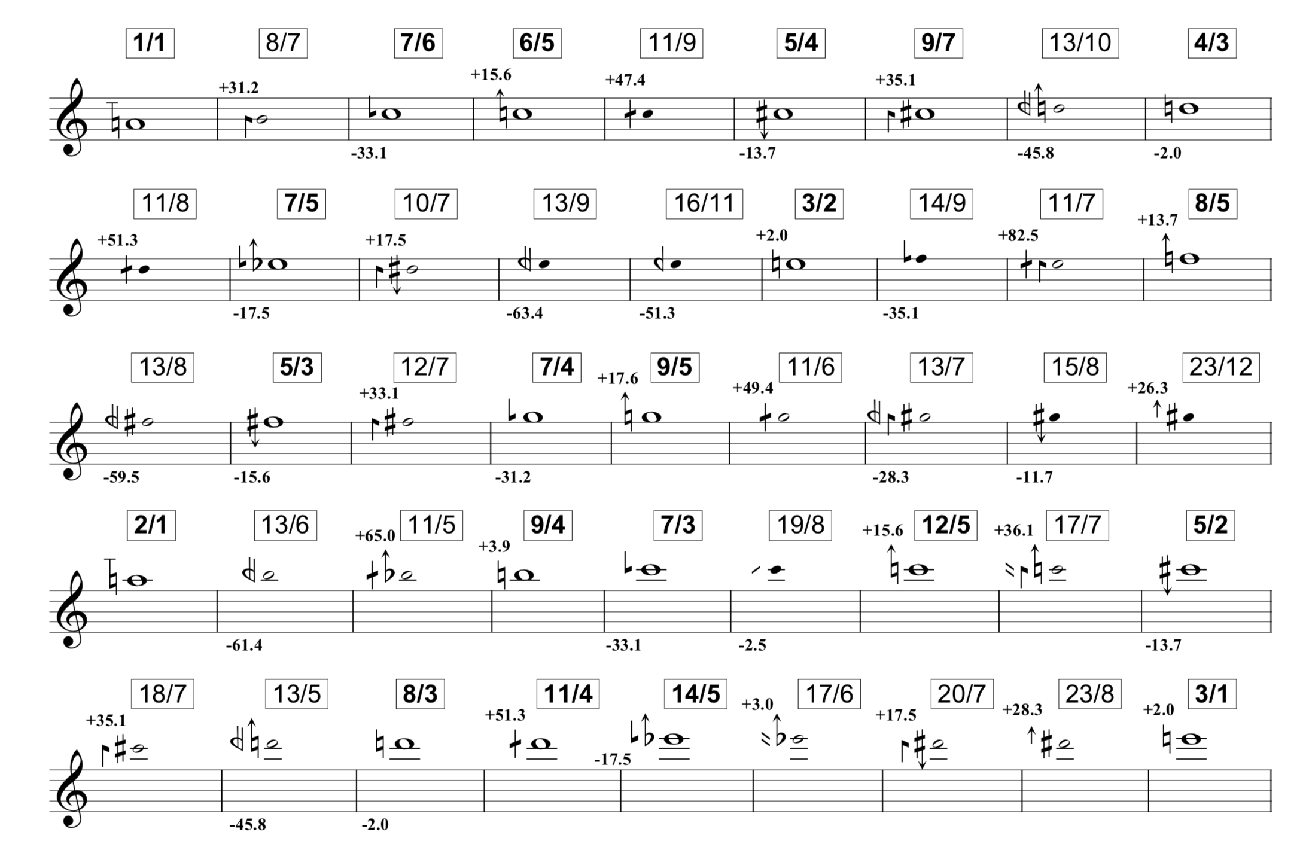

Figure 1 – Intervals tunable by ear

[2.4] The choice to print tunable intervals within a 3-octave range, rather than a 1-ocatve range, suggests that, for the authors, the empirical psychoacoustic experience of tuning Just Intonation intervals on the violin conflicted with Partch’s octave equivalence. Unlike most of those ratios printed in the theoretical passages of Partch’s “Genesis of a Music”, the ratio notation in Figure 1 is not reduced into odd numbers, meaning that octave equivalency is not assumed in the ratio notation.

[2.5] It is further notable that some intervals occur only in Figure 1 as simple intervals, or only as compound intervals. For example, 8/7, a semitone expanded by 31.2 cents (approximately one-third of a semitone) appears as a tunable interval, but its compound corollary 16/7, which would be a sharpened minor ninth, does not appear on the chart. Similarly, the interval 17/7 appears as a tunable-by-ear sharpened minor tenth, while 17/14, the same interval reduced into the octave, does not appear on the chart.

[2.6] The full 3-octave chart includes 92 intervals. The highest number in the numerator of any interval on the chart is 28, while the highest number in the denominator of any interval is 11. For this chart, 440Hz has been chosen as 1/1, the center frequency against which all other frequencies are compared.

**III. Harmony Matrix Background**

[3.1] A Harmony Matrix analysis can be constructed in order to use lines and color to visualize the ratio relationships among these Just Intonation tones, when sounded in various combinations with one another. A matrix of 28x15 pixels can be constructed, such that numerators are numbered along the x axis from 1 to 28, while denominators are numbered along the y axis from 1 to 11.

[3.2] Each pixel location (x,y) is assigned a frequency, determined by the equation:

PixelFrequency = CenterFrequency \* x / y

[3.3] The top and leftmost point of the matrix, the location (1,1), is therefore assigned to the center frequency 440Hz. Each pixel can be on or off—on pixels are brightly colored, while off pixels are dimly lit. The hue of each pixel is determined by its pitch class, with the pitch class of the location (1,1) assigned to red.

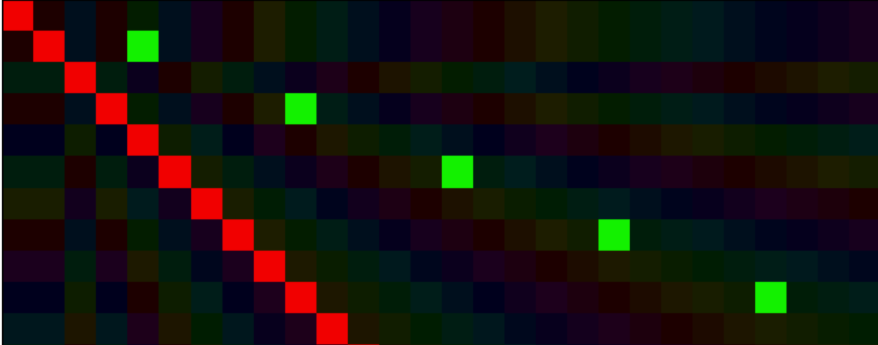

Figure - Example Harmony Matrix showing the center frequency diagonal and L-shape equivalency

[3.4] While each pixel connotes one frequency, some frequencies correspond to multiple pixel locations. For example, the locations (2,2), (3,3), (4,4) and so forth, all correspond to the center frequency. When the center frequency is considered in a harmony matrix analysis, all the pixels that correspond to this frequency are illuminated, creating a red line across the main diagonal. Other locations sharing equivalent frequencies create regular patterns of identical color boxes, arranged in “L” shapes, similar to a knight motion in chess. The graphic below displays 440Hz, represented by the red center frequency across the main diagonal, as well as 1100Hz, represented by the green at (5,2), (10,4), (15,6), (20,8), at (25, 10).

[3.5] In order to distinguish notice a singular frequency with multiple pixel locations, it is important to learning to recognize this duplicate pixel representation, which features an “L”-pattern extending from the top left to the lower right made of same color pixels. It is useful to note that pixel locations that represent the same frequency can never appear together in a line, or as diagonals, with the sole exception of the center frequency diagonal.

[3.6] Adjacent pixels in the top edge and left edge of the Harmony Matrix display consonant interval represented by very small whole numbers—such as the octave 2/1, the fifth 3/2, the fourth 4/3, and the third 5/4. As the bottom right of the matrix is approached, the intervallic space between neighboring pixels—both on the x and y axis—decreases.

[3.7] The hues of the Harmonic Matrix graphic correspond to pitch class, mapped with the aid of MaxMSP. Identical hues, which do not appear as part of a shared multiple pixel L-pattern, correspond to frequencies an octave apart. Most prevalent in the bottom right of the matrix between diagonally connect pixels, hue angle differences on the threshold of perception suggest frequencies close enough to be heard as two detuned voices of the same pitch. Hues that are nearby—such as red and orange—suggest two frequencies heard as two distinct pitches, at or closer than a whole tone. The musical distance between colors in the color triad is roughly a third—the distance between complementary colors is roughly a tritone.

[3.8] To illustrate color interpretation, the tones 220Hz, 440Hz (center), 520Hz, 528Hz, 660Hz, are represented in the following graphic:

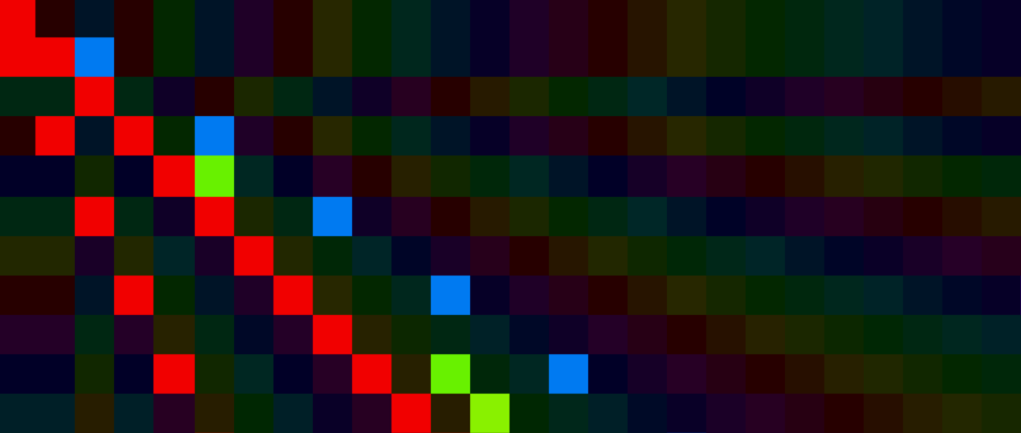

Figure 3 – Example harmony matrix showing the three possible meanings of apparently identical hue.

[3.9] The two similar red lines represent an octave; the leftmost red L-pattern is 220Hz, and the center frequency line is 440Hz. 440Hz, 528Hz, and 660Hz form a Just Intonation minor triad, noticeable as a red, green, and blue vertical line (6,5), (6,6) and (6,7). 528Hz has two pixel location representations—at (6,5) and (12,10). The two green pixels in the bottom right diagonal to one another at (13,11) and (12,10) represent 520Hz and 528Hz respectively, which appear to merge into a single pitch with beating.

[3.10] In addition to color, any straight lines connecting brightened pixels are potentially musically significant. It is notable that the harmonic series built on a 440Hz extends left to right from the bitr(1,1) point, while the subharmonic series built underneath 440Hz extends up to down from the (1,1). Each horizontal line from (1, y) to (28, y) is a harmonic series built on the fundamental 440Hz \* 1/y, and each vertical line from (x,1) to (x,11) is a subharmonic series constructed downwards from the tone 440Hz \* x.

[3.11] These lines have a hierarchy of psychoacoustic meaning, depending on their direction, density, location, and length. Lines of two pixels represent small, whole-number ratios between tones. A horizontal line, broken or unbroken, with three or more brightened pixels represents a harmonic series excerpt, psychoacoustically meaningful anywhere on the Harmonic Matrix, unless all x values are only higher primes.

[3.12] Vertical lines of three or more notes, are more psychoacoustically meaningful when they appear towards the top of the matrix. The sonorities represented by vertical lines near the top include those that can be extracted from the subharmonic series, such as Just Intonation minor chords and half-diminished chords. Vertical lines of three or more tones from dissonant cluster chords as the Harmony Matrix progresses downwards, and the relationships described by vertical lines low on the Harmony Matrix tend not to be psycho-acoustically relevant.

[3.13] The graphics provided in this section make use of a 440Hz center frequency, a numerator maximum of 28, and a denominator maximum of 11. In practice, each Harmonic Matrix analysis must first choose a center frequency, which will help determine numerator and denominator maximums. A center frequency can be chosen due to its musical relevance to the analysis passage, by adopting the Just Intonation composer’s original choice of 1/1, or by searching for the center frequency that will permit for the smallest dimensions possible. Determining the dimensions of the matrix requires listing the ratio of each frequency in the analysis passage with respect to the center frequency, then selecting the maximum of the numerators and the maximum of the denominators as matrix dimensions.

**IV. Violin Octet**

[4.1] Chris Otto’s Violin Octet explores the boundaries between rhythm, harmony, and timbre by integrating the mathematics polyrhythmic structures with ratio-based Just Intonation harmonic structures. As incomplete harmonic series structures are slowly built and deconstructed, the resultant effect meanders between that of a richly constructed chord, and a morphing timbre.

[4.2] Otto’s own harmonic analysis subdivides the 2 hour octet into 9 sections, with increasingly lower fundamentals—from 42Hz, 21Hz, eventually to 4.2Hz, to “asymptotically approaching zero” (2014). The bottom staff indicates the fundamental frequency in each section, in relationship to 42Hz, the first fundamental of the piece. The fundamental frequency itself is theoretical—it is never heard during the piece. The top eight staves indicate notes played by the detuned violins, notated in Helmholtz-Ellis, along with a frequency multiplier that can be applied to the sectional fundamental.

Macintosh HD:Users:DavidBeyer:Downloads:Fw%3a_Score_of_Violin_Octet_(Chris_Otto):arcana example 3.pdf

Figure 4 – Pitch material from Chris Otto’s violin octet.

[4.3]Before conducting Harmonic Matrix analysis, it is interesting to note the degree of extreme parsimony in the voice leading—there is not a melodic voice that travels within a range wider than a minor third. There is little variation in coarse pitch. Instead, the forward trajectory instead relies on miniscule pitch adjustments, which change the harmonic ratio context of each tone in relation to an implied fundamental. Harmonic Matrix Analysis will illuminate these changes.

[4.4] The 1/1 provided by Otto, 42Hz, also provides the smallest numerator and denominator size out of all possible fundamentals. All fixed pitches in the octet can be represented using a 42Hz center frequency with a 66x15 matrix. Due to space constraints and software considerations, all graphics will be presented as 32x16.

**V. Harmonic Matrix Analysis of Section 1**

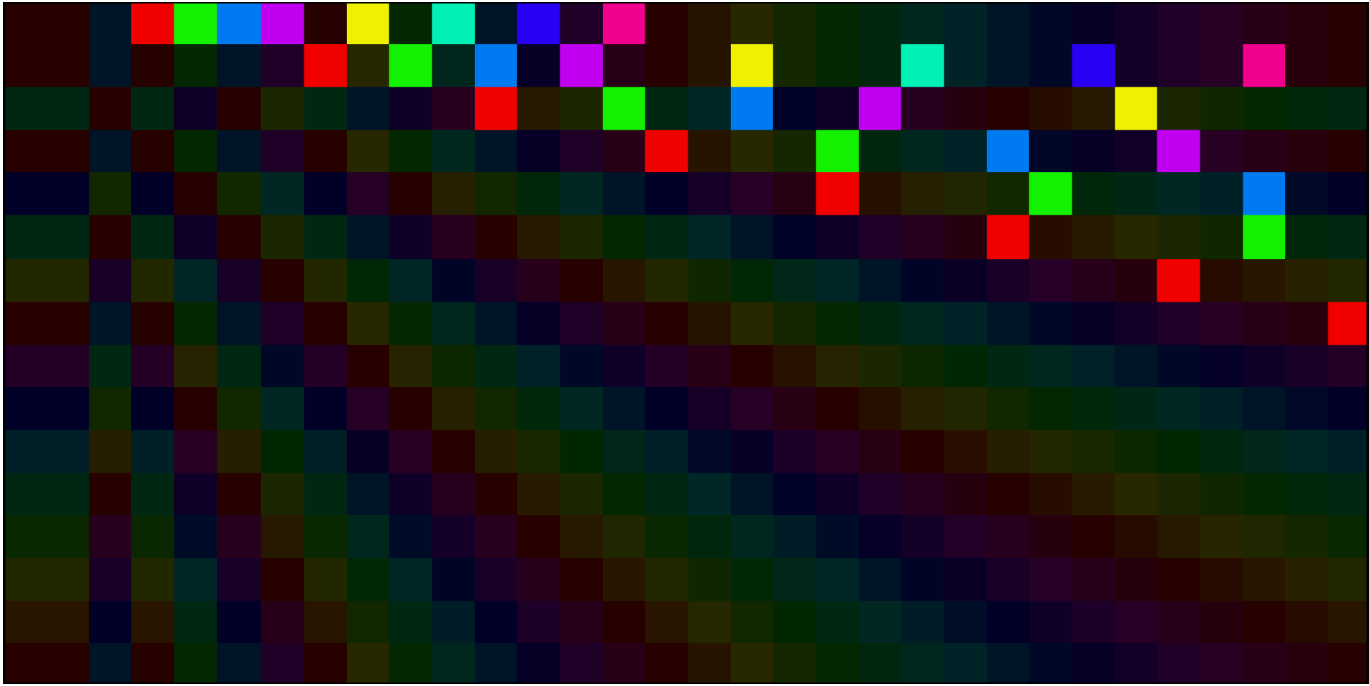[5.1] Section 1 begins with harmonics 4, 5, 6, 7, 9, 11, 13, and 15 of 42Hz:

Figure 5 - Harmonic Matrix analysis of section 1.

[5.2] The strongest line in this matrix is from (4, 1) to (15,1), because it includes all 8 pitches in their densest form, with their highest fundamental. The line starts unbroken, meaning that the spectra includes both odd and even harmonics, then becomes “checkered.”

[5.3] Searching for color matching in rows 1 and 2 helps to show how (8, 2) is an equivalent pixel to (4,1), (10,2) is equivalent to (5,1), (12, 2) is equivalent to (6,2), and (14,2) is equivalent to (7, 1). The checkered pattern demonstrates how the gaps between harmonics 9, 11, 13, 15 would be filled if harmonics 4, 5, 6, 7 were transposed an octave up.

[5.4] This chord contains a variety of colors, including colors that have small intervallic distance, on the order of less than a whole step. This chord does not contain any colors that show octave doubling or fusing tones. This color information represents that this chord will form a rich, largely evenly spaced texture without significant audible beating.

**VI. Harmonic Matrix Analysis of Section 2**

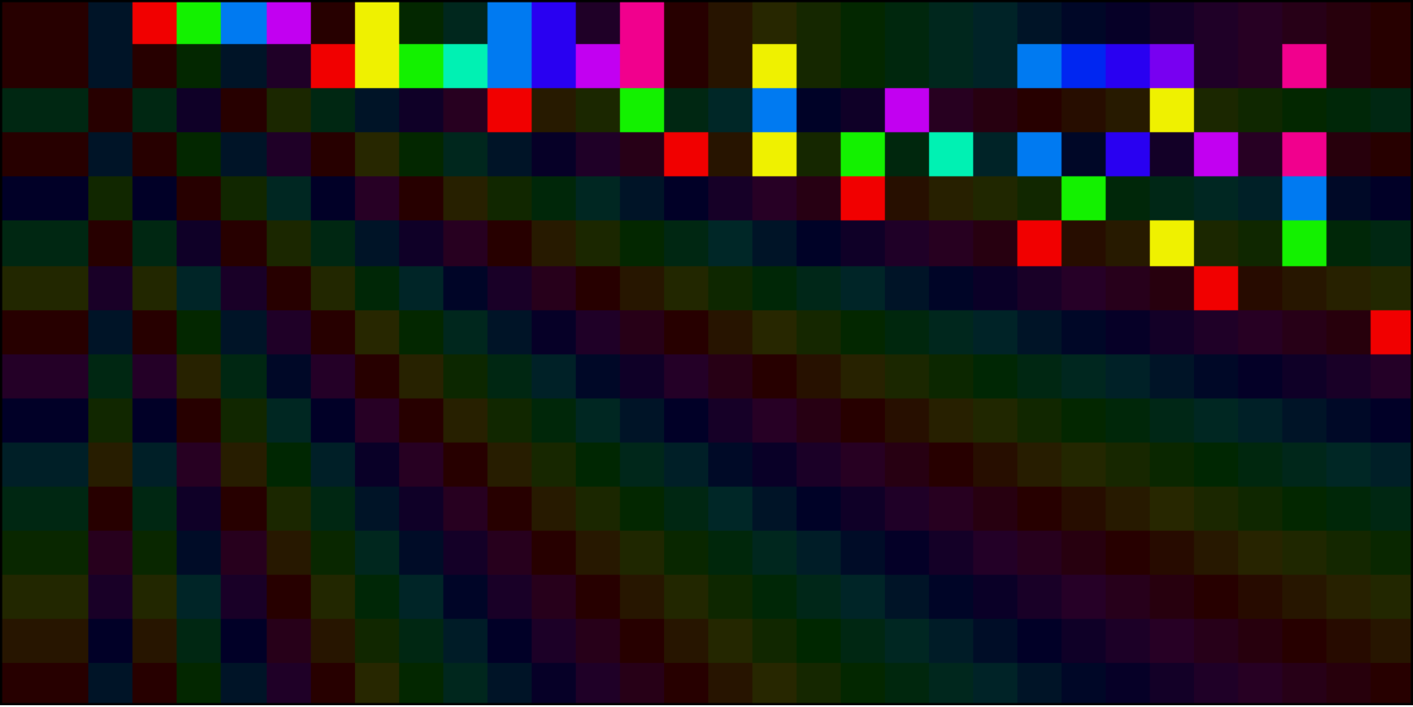

[6.1] In columns 4 through 15, the colors on the section 2 matrix match the colors from the section 1 matrix. This demonstrates that no pitch classes have been removed from section 1—although octave voicing has changed. The same-color rectangles in columns 9, 12, 13, and 15 show that these pitches are octave doubled.

[6.2] The line on row 1 remains strong with 8 members, five of which are adjacent to one another. The line on row 2 is stronger, with 14 members, 12 of which are adjacent. The row 2 spectra starts out unbroken from 8-15, then does not return to full strength until 24. The 8-15 will create a thick, harmonically rich chord with the octave doublings present. The horizontal line from 24-27 in row 2 being so analogous in color, is a microtonal cluster chord that creates significant audible beats and difference tones.

[6.4] Overall, a shared fundamental in row 2 unites a thick chord in the lower register with beating clusters in the middle register, without removing pitch class material from section 1. As the piece continues, the fundamental lowers as the superparticular ratios, slowly tighten in intervallic size over the course of the piece from dissonant, to more intensely, dissonant, to beating more slowly, to unison.

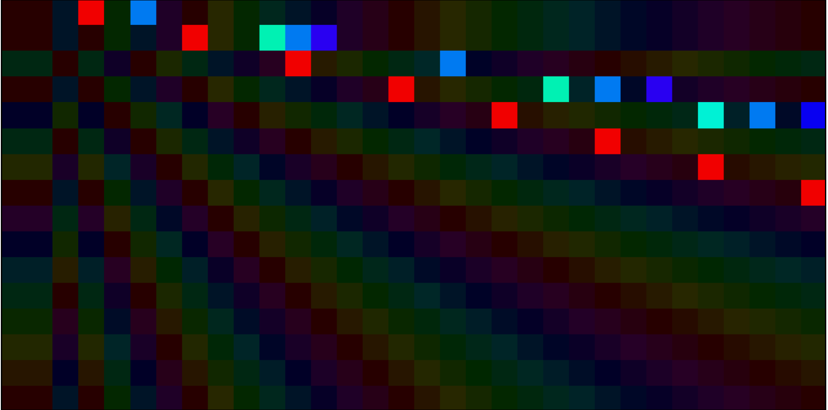**VII: Harmonic Matrix Analysis of Section 9**

[7.1] While the sectional fundamental is available on this matrix at (1,10), its partials 40, 55, 56, 60, 64 and 65 cannot appear in row 10 in a 32x16 display. This is fine, because these ratios do reduce into 4/1, 11/2, 6/1, 32/5, and 13/2 which all appear on the 32x16 display, some in multiple pixel locations.

[7.2] There are two pixels that appear to be part of “L” equivalency patterns, but are not. The teal (11, 2) and (22,4) are both equivalent to partial 55—and the (32,5) is not in the correct location to continue the L—it is the partial 56. Similarly, (13,2) and (26,4) are equivalent as partial 65, but (32,5) is more royal and less periwinkle, as partial 64. This analogous hue trickery makes sense—at this point in the piece, the super particular ratios have almost merged into single tones.

[7.3] The strongest musical shape in this matrix is the “T” from columns 11 to 1. This “T” illustrates that partials 55, 60, 65 form an adjacent excerpt of the harmonic series of 21Hz, and that partial 40 sounds a fifth below partial 60.

[7.4] The four pixel lines in rows 4 and 5 demonstrate that the pitches in this section can be constructed by adding selected harmonics from the fundamentals 42\*1/4 Hz and 42\*1/5Hz. Each pixel has an adjacent or separated by one relationship to at least two others pixel, meaning that despite the miniscule microtonal intervals at play, every tone is engaged in a consonant relationship with at least two other tones. This matrix contains only a few colors—it will much harmonically thinner than section 2, with audible combination tones and beating as the superparticular ratios approach unison.

**VIII: Conclusions**

The Extended Helmholtz-Ellis JI pitch system defines a system of 67 accidentals to exactly notate microtonal pitch based on harmonic ratio function, at the cost of readability of fine pitch and harmonic function to the uninitiated, as well as historical context. Harmonic Matrix Analysis reveals intervallic distance and harmonic ratio function through color, position, adjacent pixels, lines, and density.

The Harmonic Matrix Analysis of Chris Otto’s octet leads focused around 42Hz as the center frequency. Section 1 began with a texturally full chord voiced without octave doubling, built from the harmonic spectra of 42Hz. Section 2 revoiced and added octave doublings to the sonority from Section 1, while adding microtonal cluster chords.

Harmonic Matrix Analysis of Section 9 illustrated how Otto utilized sonorities of tunable consonances derived from multiple harmonic spectra, in order to provide a consonant context to increasingly miniscule intervals employed throughout the piece, which coalesce gradually from a semitone to a syntonic comma to unison.

**Works Cited:**

Otto, Chris. "Violin Octet." In Arcana VII: Musicians on Music, edited by John Zorn. Hips Road/Tzadik, 2014.

Sabat, Marc, Wolfgang von Scheinitz, and Natalie Pfeiffer. "The Extended Helmholtz

Ellis JI Pitch Notation." Marc Sabat: Music and Writings. 2005. Accessed May

11, 2018. http://www.marcsabat.com/pdfs/notation.pdf.

Partch, Harry. *Genesis Of A Music: An Account Of A Creative Work, Its Roots, And Its Fulfillments*. Boston, MA: Da Capo Press, 1979.

"Violin Octet." Christopher Otto to David Beyer. March 26, 2018.